STOCK PRICE PREDICTION

PHASE I REPORT

Submitted to:-
Supervisor:- Ms. Harsh Sharma (E13523)
Co Supervisor:- Mr. Siroj Kumar Singh (E13617)

NAME OF THE CANDIDATE(S)
NAME - UID
ANMOL SHAKYA - 20BCS5146
BUNTY PRASAD NAYAK - 20BCS1160
DEVANSH TIWARI - 20BCS1235

in partial fulfillment for the award of the degree of

BACHELOR OF ENGINEERING
IN
COMPUTER SCIENCE AND ENGINEERING


Chandigarh University
OCTOBER 2022

CHAPTER 1

INTRODUCTION

Client Identification/Need Identification/Identification of relevant Contemporary issue
- Stock Market - Refers to several exchanges in which shares of publicly held companies are bought and sold.
- “Stock market” and Stock exchange” are often used interchangeably. Traders in the stock market buy or sell shares on one or more of the stock exchanges.
- Stock market: The process and facilitation of investors buying and selling stocks with one another.
- Stock exchange: The actual intermediary that connects buyers with sellers.
- Stock Price: Factors that can affect the price.
1- An earnings base.
2- A valuation multiple.
- An earnings base: we use EPS, an accounting measure, to illustrate the concept of earnings base. The way earnings power is measured may also depend on the type of company being analyzed.
- A valuation multiple: The valuation multiple expresses expectations about the future. As we already explained, it is fundamentally based on the discounted present value of the future earnings stream. Therefore, the two key factors here are:
1- The expected growth in the earnings base
2- The discount rate.
Identification of relevant Contemporary issue -
- Commodity Price Risk.
- Headline Risk.
- Inflationary Risk and Interest Rate Risk.
- Model Risk.

Identification of Problem
- Stock market is one of the fastest ways of making money but there is risk also. Like if we purchase Stock of any company than there is no guarantee that in future, he/she can gain big profit, there is more chance that he/she in loss.
- Stock market of company that user spending money that a higher chance that price of that company stock is not stable .so it is defect to predict the price of Stock market. It always goes up and down quickly.

Identification of Tasks
Stock market prediction and analysis are some of the most difficult jobs to complete. There are numerous causes for this, including market volatility and a variety of other dependent and independent variables that influence the value of a certain stock in the market. These variables make it extremely difficult for any stock market expert to anticipate the rise and fall of the market with great precision.

Timeline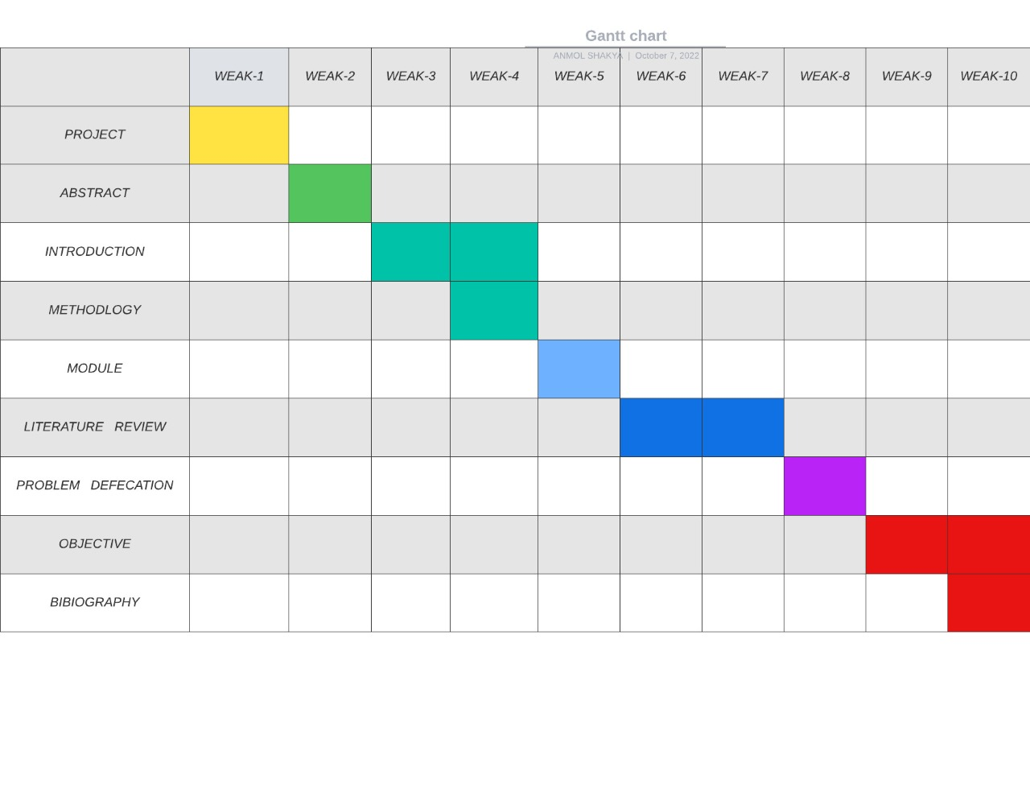

Organization of the Report
The material presented at the report is organized into five chapters. After this introductory chapter 1, chapter 2 describes the “Literature survey” by reading previous year papers for the project “Stock Market Prediction” using Machine Learning.

Chapter 1 describe the brief and Identification/Need Identification/Identification of relevant Contemporary issue of the project

Chapter 2 gives us the literature review , review summary , and goals and objective of the project.

Chapter 3 describes the Design flow/Process that are followed in our project for the development of project stock market prediction. It defines the various steps and processes in which our project is divided.

Chapter 4 provides Results analysis and validation of our project. In this we will evaluate our project on the basics of the final outcome that we received after the proper deployment of the project.

Chapter 5 presents the Conclusion and the future work of our project. In this chapter we will discuss the future of our project and also conclude our project on the various results that we got from the previous Chapter 4. In future scope we will also define the various sectors where we can deploy our project and how it will benefit the user.

REFERENCES
- A. Ben-Hur and J. Weston. A user's guide to support vector machines. In O. Carugo and F. Eisenhaber (eds.), Data Mining Techniques for the Life Sciences, pp. 223--239. Springer, 2010.
- Bing Search API. Windows Azure Marketplace.
- N. K. Chowdhury and C. K.-S. Leung. Improved travel time prediction algorithms for intelligent transportation systems. In Proc. KES 2011, Part II, pp. 355--365.
- A. Cuzzocrea, C. K.-S. Leung, and R. K. MacKinnon. Mining constrained frequent itemsets from distributed uncertain data. FGCS, 37: 117--126, July 2014.
- T. Finley and T. Joachims. Training structural SVMs when exact inference is intractable. In Proc. ICML 2008, ACM, pp. 304--311. ACM.
- D. Hodges. Is your fund manager beating the index? MoneySense, 15(7):10, Dec. 2013/Jan. 2014.
- T. Joachims, T. Finley, and C.-N. J. Yu. Cutting-plane training of structural SVMs. Machine Learning, 77(1): 27--59, Oct. 2009.
- D. E. King. Dlib-ml: a machine learning toolkit. JMLR, 10: 1755--1758, July 2009.
- V. Kolmogorov and C. Rother. Minimizing nonsubmodular functions with graph cuts-a review. IEEE TPAMI, 29(7): 1274--1279, July 2007.
C. K.-S. Leung, F. Jiang, and Y. Hayduk. A landmark-model based system for mining frequent patterns from uncertain data streams. In Proc. IDEAS 2011, pp. 249--250. ACM.

